*Please note: Summer offerings will be limited. All courses will be online and instructional materials may be limited, which will also impact course availability.

- Students new to HCC Dual Enrollment or Early Admissions will start at step #1.
- Students who are existing Dual Enrollment or Early Admissions will start at step #5.

STEPS:
- Meet Eligibility Requirements
  - Dual Enrollment - (enrolled in up to 10 credit hours per term)
    - Be in enrolled in a Florida Public, Private, Charter, or Home Education Program
    - Have an unweighted 3.0 high school GPA
*Students must maintain a 3.0 unweighted high school GPA and a 2.0 HCC GPA to remain eligible.
  - Early Admission- (enrolled in a minimum of 12 credit hours (Full time) and a maximum of 15 credit hours per semester)
    - Entering 12th grade
    - Have an unweighted 3.5 high school GPA at the end of 11th grade
    - Not in the running for a distinction (Valedictorian or Salutatorian)
    - Have completed all requirements for high school graduation or have one or more of the following courses remaining:
      - 1 credit of English and/or 1 credit of Math and/or .50 credit of Economics and/or .50 credit of American Government
    - Score at college level on SAT, ACT and/or PERT

- Complete the HCC Dual Enrollment/Early Admissions Application for Admission
- Complete application online at: https://www.hccfl.edu/admissions/apply-online.
  - Students will create an account (use an email address you check regularly).
  - Students will start Dual Enrollment/Early Admissions Application by completing all required fields, certify and submit the application
  - When you complete your application, the student will receive an email with your HCC student ID# and your Hawkmail email address. It is important you retain this information.

- Register Your Net ID
- This will create your NetID and Password for your Hawkmail, Webadvisor, and Canvas (MyHCC) accounts. The Dual Enrollment Office will email you periodically with information and updates to your Hawkmail account.
  - Go to https://netid.hccfl.edu. Then click Register with Password Manager.
  - Enter your NetID (Your NetID is the first part of your HawkMail address above before the "@" sign). Select Student as the role.
  - When prompted, enter your default password which is the upper-case letter of your first name, lower-case letter of your last name, followed by your student ID number listed above (i.e. Ab0999999).
  - Create your Question & Answer Profile.
  - You can now go to Manage My Passwords to change the default password to one of your choosing.
  - To access your e-mail go to https://outlook.office365.com/mail/inbox
  - Login with your full e-mail address listed above and password you just created.
  - Need help? Contact technical support at 877.736.2575 or via the HCC Live webpage.

- Submit Test Scores (ACT, SAT, PERT)
- If the student has PERT scores, HCC will automatically look for PERT scores or if the student was previously approved for dual enrollment, HCC has the test scores on file.
- If the student doesn’t have qualifying test scores on file with HCC, but has ACT or SAT scores, the student will need to send those scores to HCC via the dual enrollment email address: dualenrollment@hccfl.edu.
  - The student will need to obtain your scores from your respective test score account:
    - ACT scores
    - SAT scores
      - If you are submitting SAT scores, you will need to print your detailed score report that has your 2 digit scores.
  - Your scores cannot be older than two years from the first day of the semester you plan to attend.
  - Please note: If the student doesn’t currently have test scores, there is discussion at the state level about using PSAT scores to serve as qualifying test scores for dual enrollment. The student may still apply for dual enrollment and the required paperwork can still be submitted while we wait for information regarding options for students who don’t currently have qualifying test scores.
  - This table shows the minimum placement test scores required for eligibility:
PERT | SAT | ACT
Reading 106 | Reading 24.0 | Reading 19
Writing 103 | Not Applicable | English 17
Math 114* | Math 24.0* | Math 19*
* MAC 1105 requires 123 for PERT, 27.0 for SAT and 21 for ACT

- Submit Paperwork for Approval and Register for Classes
- Prior to receiving the proper form to complete, the student will need to let the school counselor know which courses they would like to take for the specific enrollment term (fall, spring or summer).
  - Students should consult with their high school guidance counselor for high school graduation requirements or the Course Equivalency List.
  - Students can sit down with an HCC Advisor to discuss degree transfer tracks.
  - HCC strongly recommend students follow the Associate in Arts curriculum.
  - Dual Enrollment students cannot take preparatory or remedial courses, physical education courses or courses less than 3 credit hours.
- Effective Fall 2020, all dual enrollment students and their parents or guardians must sign the Dual Enrollment Student and Parent Agreement and submit it as part of their paperwork for approval to register for classes.
- Student will need to request the dual enrollment paperwork from their school counselor. The school counselor will then email page two of Form B (dual enrollment) or Form C (early admission) to the student. Both the student and parent will need to complete the form and returned to the counselor via email or Edsby (even if it is just the electronic version of the student and parent initials and signatures).
- School counselor will fully complete page one of Form B (dual enrollment) or Form C (early admission) and will send both pages (1 and 2) of appropriate form to HCC.
  - The school counselor sending page one of Form B or Form C to HCC serves as verification that the student has the minimum required GPA for dual enrollment or early admission.
- Once the student is approved for dual enrollment, they will get an email from the dual enrollment office regarding the next steps (i.e. course registration).

- Get Your Textbook
  - You can access which textbooks are needed for your course by visiting the campus bookstore or accessing the online bookstore.
  - Hillsborough County Public Schools has created detailed instructions on obtaining textbooks - HCPS textbook information is available here. The Hillsborough County Public School Textbook Warehouse can have an order time of up to 15 days. If a student registers for classes less than 15 days prior to a class starting, they run the risk of not having a textbook when the course starts. The Dual Enrollment office does not have access to textbook ordering.

Important Dates and Deadlines
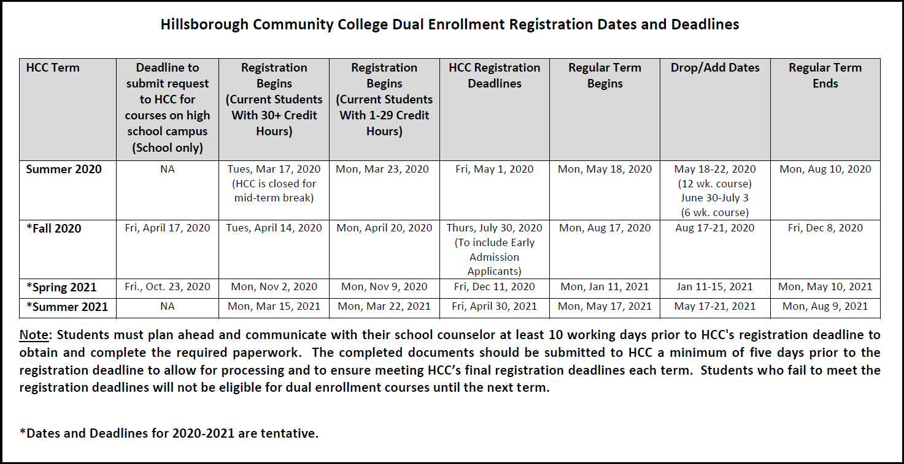
What happens if I am unsuccessful or withdraw from a course?
- Withdraw: Students who drop a class after the published drop date will receive a W on their transcript, and this will count as an attempt of the course. Withdrawing does not affect the student’s high school or college GPA. Dual Enrollment students are eligible for one attempt per course.
- Earning a grade below a C: Students who earn a D or an F in a course will be considered "not passing." The grades will go back on their high school transcript and be permanent on their college record.
- Students who have earned a W or a non-passing grade can use a one-time Dual Enrollment Petition. Students are to submit petitions to the Dual Enrollment office for review, and the student will receive an email whether the petition is approved or denied (this can take up to 6 weeks.)

Who can I speak to for more information on Dual Enrollment?
- Dual Enrollment staff can assist you if you have additional questions: 813.253.7121, 813.253.7062 or dualenrollment@hccfl.edu

